**ELUMALAI B**

**230701084**

**Ex. No.:2.1**

**Count the occurrence**

**PROGRAM**

import java.util.Scanner;

public class Occurrence {

public static void main(String[] args) {

Scanner scanner = new Scanner(System.in);

int n = scanner.nextInt();

int[] nums = new int[n];

for (int i = 0; i < n; i++) {

nums[i] = scanner.nextInt();

}

int original = scanner.nextInt();

int currentValue = original;

boolean found;

do {

found = false;

for (int i = 0; i < n; i++) {

if (nums[i] == currentValue) {

found = true;

break;

}

}

if (found) {

currentValue *= 2;

}

} while (found);

System.out.println(currentValue);

}

}

**OUTPUT**

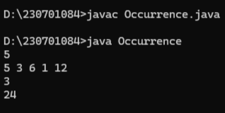

**Ex. No.:2.2**

**Inventory Management**

**PROGRAM**

import java.util.Scanner;

public class Management {

public static void main(String[] args) {

Scanner scanner = new Scanner(System.in);

int n = scanner.nextInt();

int[] prices = new int[n];

for (int i = 0; i < n; i++) {

prices[i] = scanner.nextInt();

}

int minPrice = Integer.MAX_VALUE;

int maxProfit = 0;

for (int price : prices) {

if (price < minPrice) {

minPrice = price;

}

int profit = price - minPrice;

if (profit > maxProfit) {

maxProfit = profit;

}

}

System.out.println(maxProfit);

}

}

**OUTPUT**

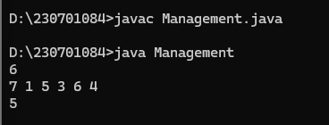

**Ex. No.:2.3**

**Sort an array of 0s, 1s and 2s**

**PROGRAM**

import java.util.Scanner;

public class Sort012 {

public static void main(String[] args) {

Scanner scanner = new Scanner(System.in);

int n = scanner.nextInt();

int[] arr = new int[n];

for (int i = 0; i < n; i++) arr[i] = scanner.nextInt();

scanner.close();

int low = 0, mid = 0, high = n - 1;

while (mid <= high) {

if (arr[mid] == 0) {

int temp = arr[low];

arr[low++] = arr[mid];

arr[mid++] = temp;

} else if (arr[mid] == 1) {

mid++;

} else {

int temp = arr[high];

arr[high--] = arr[mid];

arr[mid] = temp;

}

}

for (int num : arr) System.out.print(num + " ");

}

}

**OUTPUT**

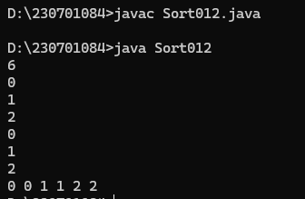

**Ex. No. :2.4**

**Find the Missing Number**

**PROGRAM**

import java.util.Scanner;

public class Missingnumber {

public static void main(String[] args) {

Scanner scanner = new Scanner(System.in);

System.out.print("Enter the size N: ");

int N = scanner.nextInt();

int[] arr = new int[N-1];

System.out.print("Enter the array elements: ");

for (int i = 0; i < N-1; i++) {

arr[i] = scanner.nextInt();

}

int totalSum = N * (N + 1) / 2;

int arrSum = 0;

for (int i = 0; i < N-1; i++) {

arrSum += arr[i];

}

int missingNumber = totalSum - arrSum;

System.out.println("The missing number is: " + missingNumber);

}

}

**OUTPUT**

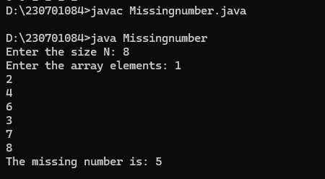

**Ex. No. :2.5**

**Move all Zeroes to the End of the Array**

**PROGRAM**

import java.util.*;

public class Movezero{

public static void main(String[] args){

Scanner sc = new Scanner(System.in);

int n=sc.nextInt();

int[] arr = new int[n];

for(int i=0;i<n;i++){

arr[i] = sc.nextInt();

}

int j=0,count=0;

for(int i=0;i<n;i++){

if(arr[i]==0){

count++;

}

else{

arr[j]=arr[i];

j++;

}

}

for(int i=j;i<n;i++){

arr[i]=0;

}

for(int i=0;i<n;i++){

System.out.print(arr[i]+" ");

}

}

}

**OUTPUT**

